Real Numbers Set
# Source: AI Source: Provided by: [Data Path: Persons Table -> ID Column: 1, Name_En Column: Motasem Essam] -> From: [ChatGPT] on [7/15/2026]
The Real Numbers Set is the set of all rational and irrational numbers. Real numbers include every number that can be represented on the number line, including positive numbers, negative numbers, zero, fractions, terminating decimals, repeating decimals, and irrational numbers.
The Real Numbers Set is one of the most important number sets in mathematics and forms the foundation of algebra, geometry, trigonometry, calculus, analysis, statistics, engineering, physics, computer science, and many other disciplines.

Definition
# Source: AI Source: Provided by: [Data Path: Persons Table -> ID Column: 1, Name_En Column: Motasem Essam] -> From: [ChatGPT] on [7/15/2026]
The Real Numbers Set consists of all numbers that can be represented as points on the real number line.
It is denoted by
$$\boxed{R}$$
The set contains both:
- Rational numbers
- Irrational numbers

Symbol
# Source: AI Source: Provided by: [Data Path: Persons Table -> ID Column: 1, Name_En Column: Motasem Essam] -> From: [ChatGPT] on [7/15/2026]
The standard symbol for the Real Numbers Set is
$$\boxed{R}$$

Set Notation
# Source: AI Source: Provided by: [Data Path: Persons Table -> ID Column: 1, Name_En Column: Motasem Essam] -> From: [ChatGPT] on [7/15/2026]
The Real Numbers Set can be expressed as
$$\boxed{R=Q∪(R-Q)}$$
meaning:
Real Numbers = Rational Numbers ∪ Irrational Numbers

Set-Builder Notation
# Source: AI Source: Provided by: [Data Path: Persons Table -> ID Column: 1, Name_En Column: Motasem Essam] -> From: [ChatGPT] on [7/15/2026]
$$\boxed{R=\{ x∣x\text{ is any number on the real number line }\}}$$

Hierarchy
# Source: AI Source: Provided by: [Data Path: Persons Table -> ID Column: 1, Name_En Column: Motasem Essam] -> From: [ChatGPT] on [7/15/2026]
The Real Numbers Set contains
$$\boxed{N⊂W⊂Z⊂Q⊂R}$$
Every natural number, whole number, integer, and rational number is also a real number.

Examples
# Source: AI Source: Provided by: [Data Path: Persons Table -> ID Column: 1, Name_En Column: Motasem Essam] -> From: [ChatGPT] on [7/15/2026]
Real numbers include
Integers
$$-5, 0, 12$$

Fractions
$$\frac{1}{2}, -\frac{7}{3}, \frac{15}{8}$$

Terminating Decimals
$$0.5, 2.75, -3.125$$

Repeating Decimals
$$0.\overset{‾}{3}, 2.\overset{‾}{18}$$

Irrational Numbers
$$π, e, \sqrt{2}, \sqrt{3}, ϕ$$

Non-Examples
# Source: AI Source: Provided by: [Data Path: Persons Table -> ID Column: 1, Name_En Column: Motasem Essam] -> From: [ChatGPT] on [7/15/2026]
The following are not real numbers:
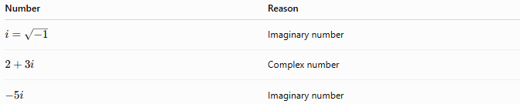
Number | Reason
$$i=\sqrt{-1}$$ | Imaginary number
$$2+3i$$ | Complex number
$$-5i$$ | Imaginary number

Characteristics
# Source: AI Source: Provided by: [Data Path: Persons Table -> ID Column: 1, Name_En Column: Motasem Essam] -> From: [ChatGPT] on [7/15/2026]
Real numbers:
- Can be positive, negative, or zero.
- Include rational and irrational numbers.
- Can be represented on the real number line.
- Form an infinite set.
- Are dense: between any two distinct real numbers there is another real number.

Properties
# Source: AI Source: Provided by: [Data Path: Persons Table -> ID Column: 1, Name_En Column: Motasem Essam] -> From: [ChatGPT] on [7/15/2026]
The Real Numbers Set is closed under the following operations (when defined):
Addition
$$a+b∈R$$

Subtraction
$$a-b∈R$$

Multiplication
$$ab∈R$$

Division
$$\frac{a}{b}∈R,b≠0$$

Algebraic Properties
# Source: AI Source: Provided by: [Data Path: Persons Table -> ID Column: 1, Name_En Column: Motasem Essam] -> From: [ChatGPT] on [7/15/2026]
Real numbers satisfy:
Commutative Property
Addition
$$a+b=b+a$$
Multiplication
$$ab=ba$$

Associative Property
Addition
$$\left(a+b)+c=a+(b+c\right)$$
Multiplication
$$\left(ab)c=a(bc\right)$$

Distributive Property
$$a(b+c)=ab+ac$$

Identity Elements
Additive identity
$$a+0=a$$
Multiplicative identity
$$a×1=a$$

Inverse Elements
Every real number has an additive inverse.
Every nonzero real number has a multiplicative inverse.

Number Line
Every real number corresponds to exactly one point on the real number line.
Likewise, every point on the real number line represents exactly one real number.

Density Property
Between any two real numbers there is another real number.
Example:
Between
$$2$$
and
$$3$$
lies
$$2.5$$
Between
$$2$$
and
$$2.5$$
lies
$$2.25$$
This process can continue indefinitely.

Examples
# Source: AI Source: Provided by: [Data Path: Persons Table -> ID Column: 1, Name_En Column: Motasem Essam] -> From: [ChatGPT] on [7/15/2026]
Example 1
Determine whether
$$5$$
is real.
Yes.

Example 2
Determine whether
$$π$$
is real.
Yes.

Example 3
Determine whether
$$\frac{4}{5}$$
is real.
Yes.

Example 4
Determine whether
$$\sqrt{2}$$
is real.
Yes.

Example 5
Determine whether
$$3+2i$$
is real.
No.
It is a complex number.

Applications
# Source: AI Source: Provided by: [Data Path: Persons Table -> ID Column: 1, Name_En Column: Motasem Essam] -> From: [ChatGPT] on [7/15/2026]
Real numbers are used in:
- Arithmetic
- Algebra
- Geometry
- Trigonometry
- Calculus
- Statistics
- Probability
- Engineering
- Physics
- Computer Science

Real-Life Applications
# Source: AI Source: Provided by: [Data Path: Persons Table -> ID Column: 1, Name_En Column: Motasem Essam] -> From: [ChatGPT] on [7/15/2026]
Real numbers are used for:
- Measurements
- Distance
- Time
- Temperature
- Finance
- Engineering calculations
- Scientific measurements
- Computer graphics
- Data analysis
- Navigation

Common Mistakes
# Source: AI Source: Provided by: [Data Path: Persons Table -> ID Column: 1, Name_En Column: Motasem Essam] -> From: [ChatGPT] on [7/15/2026]
- Confusing real numbers with rational numbers.
- Assuming irrational numbers are not real numbers.
- Believing complex numbers are real numbers.
- Forgetting that every integer is also a real number.
- Confusing repeating decimals with irrational numbers.

Key Points
# Source: AI Source: Provided by: [Data Path: Persons Table -> ID Column: 1, Name_En Column: Motasem Essam] -> From: [ChatGPT] on [7/15/2026]
- Real numbers include all rational and irrational numbers.
- Every point on the number line represents a real number.
- Real numbers exclude numbers with a nonzero imaginary part.
- Real numbers are closed under the four basic arithmetic operations (except division by zero).
- Real numbers form the foundation of classical mathematics.

Real Numbers vs. Rational Numbers
# Source: AI Source: Provided by: [Data Path: Persons Table -> ID Column: 1, Name_En Column: Motasem Essam] -> From: [ChatGPT] on [7/15/2026]
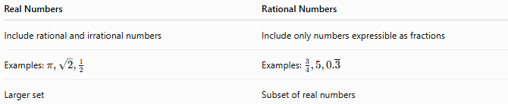
Real Numbers | Rational Numbers
Include rational and irrational numbers | Include only numbers expressible as fractions
Examples: $π,\sqrt{2},\frac{1}{2}$ | Examples: $\frac{3}{4},5,0.\overset{‾}{3}$
Larger set | Subset of real numbers

Real Numbers vs. Irrational Numbers
# Source: AI Source: Provided by: [Data Path: Persons Table -> ID Column: 1, Name_En Column: Motasem Essam] -> From: [ChatGPT] on [7/15/2026]
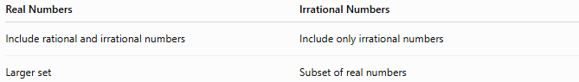
Real Numbers | Irrational Numbers
Include rational and irrational numbers | Include only irrational numbers
Larger set | Subset of real numbers

Real Numbers vs. Complex Numbers
# Source: AI Source: Provided by: [Data Path: Persons Table -> ID Column: 1, Name_En Column: Motasem Essam] -> From: [ChatGPT] on [7/15/2026]
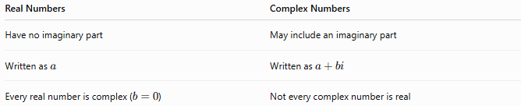
Real Numbers | Complex Numbers
Have no imaginary part | May include an imaginary part
Written as $a$ | Written as $a+bi$
Every real number is complex ($b=0$) | Not every complex number is real

Relationship to Other Number Sets
# Source: AI Source: Provided by: [Data Path: Persons Table -> ID Column: 1, Name_En Column: Motasem Essam] -> From: [ChatGPT] on [7/15/2026]
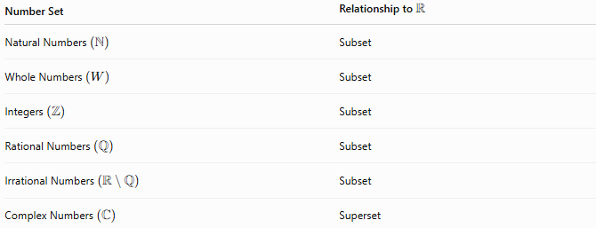
Number Set | Relationship to $R$
Natural Numbers $\left(N\right)$ | Subset
Whole Numbers $\left(W\right)$ | Subset
Integers $\left(Z\right)$ | Subset
Rational Numbers $\left(Q\right)$ | Subset
Irrational Numbers $\left(R ∖ Q\right)$ | Subset
Complex Numbers $\left(C\right)$ | Superset

Conclusion
# Source: AI Source: Provided by: [Data Path: Persons Table -> ID Column: 1, Name_En Column: Motasem Essam] -> From: [ChatGPT] on [7/15/2026]
The Real Numbers Set, denoted by $R$, is the set of all rational and irrational numbers. It contains every number that can be represented on the real number line, including integers, fractions, terminating decimals, repeating decimals, and irrational numbers such as $π$and $\sqrt{2}$. Real numbers exclude numbers with a nonzero imaginary part and provide the mathematical foundation for algebra, geometry, calculus, science, engineering, economics, and countless real-world applications.

